**Week 4- Spring-rest hands on**

**Name-Adi Jain**

**Superset ID- 6390400**

**Hands on 1**

**Create a Spring Web Project using Maven**

**Code**

**File Name: pom.xml**

<?xml version="1.0" encoding="UTF-8"?>

<project xmlns="http://maven.apache.org/POM/4.0.0" xmlns:xsi="http://www.w3.org/2001/XMLSchema-instance"

xsi:schemaLocation="http://maven.apache.org/POM/4.0.0 https://maven.apache.org/xsd/maven-4.0.0.xsd">

<modelVersion>4.0.0</modelVersion>

<parent>

<groupId>org.springframework.boot</groupId>

<artifactId>spring-boot-starter-parent</artifactId>

<version>3.5.3</version>

<relativePath/> <!-- lookup parent from repository -->

</parent>

<groupId>com.cognizant</groupId>

<artifactId>spring-learn</artifactId>

<version>0.0.1-SNAPSHOT</version>

<name>spring-learn</name>

<description>Demo project for Spring Boot</description>

<url/>

<licenses>

<license/>

</licenses>

<developers>

<developer/>

</developers>

<scm>

<connection/>

<developerConnection/>

<tag/>

<url/>

</scm>

<properties>

<java.version>17</java.version>

</properties>

<dependencies>

<dependency>

<groupId>org.springframework.boot</groupId>

<artifactId>spring-boot-starter-web</artifactId>

</dependency>

<dependency>

<groupId>org.springframework.boot</groupId>

<artifactId>spring-boot-devtools</artifactId>

<scope>runtime</scope>

<optional>true</optional>

</dependency>

<dependency>

<groupId>org.springframework.boot</groupId>

<artifactId>spring-boot-starter-test</artifactId>

<scope>test</scope>

</dependency>

</dependencies>

<build>

<plugins>

<plugin>

<groupId>org.springframework.boot</groupId>

<artifactId>spring-boot-maven-plugin</artifactId>

</plugin>

</plugins>

</build>

</project>

**========================================================**

**File Name: SpringLearnApplication.java**

**package** com.cognizant.spring_learn;

**import** org.springframework.boot.SpringApplication;

**import** org.springframework.boot.autoconfigure.SpringBootApplication;

**import** org.slf4j.Logger;

**import** org.slf4j.LoggerFactory;

@SpringBootApplication

**public** **class** SpringLearnApplication {

**private** **static** **final** Logger ***LOGGER*** = LoggerFactory.*getLogger*(SpringLearnApplication.**class**);

**public** **static** **void** main(String[] args) {

***LOGGER***.info("Start");

SpringApplication.*run*(SpringLearnApplication.**class**, args);

***LOGGER***.info("End");

}

}

**========================================================**

**Output**

**Folder Structure**

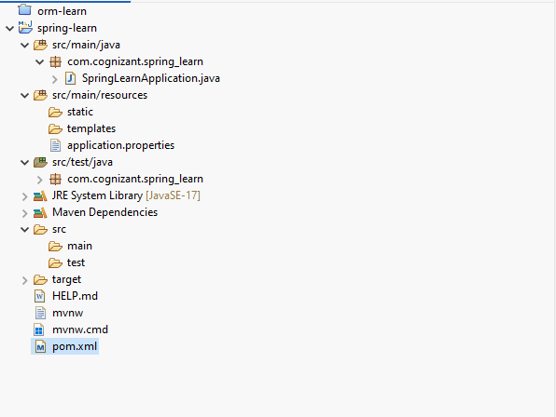

**========================================================**

**Final Output**

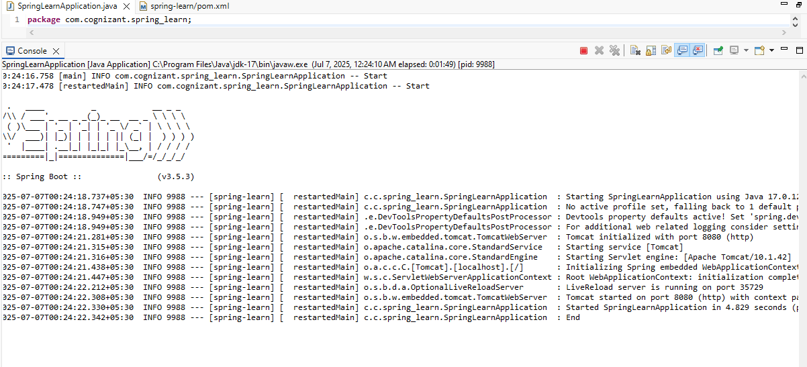

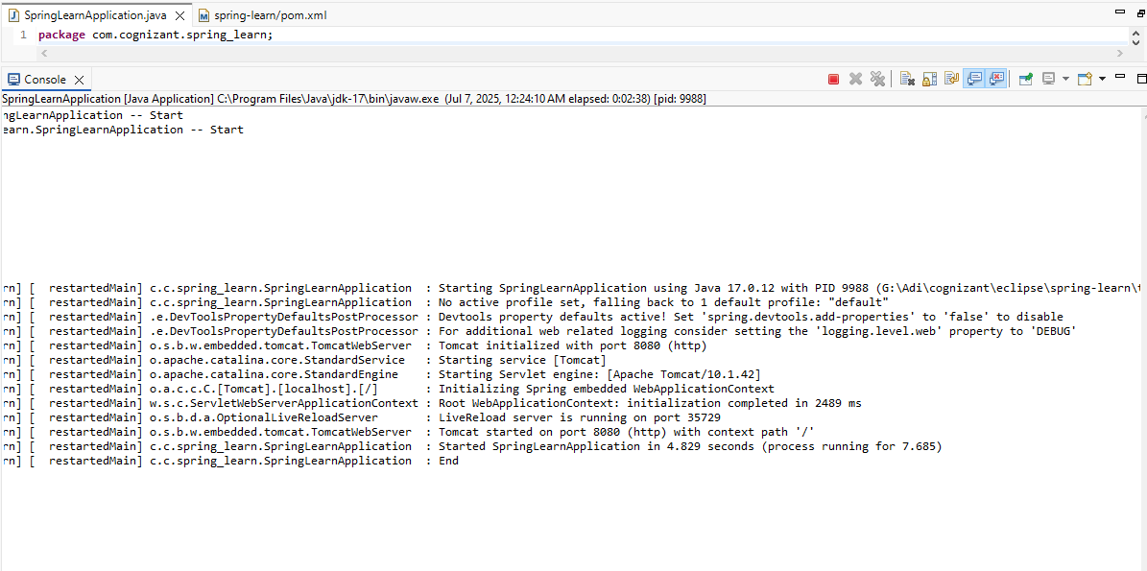

**========================================================**

**Hands on 4**

**Spring Core – Load Country from Spring Configuration XML**   
  
An airlines website is going to support booking on four countries. There will be a drop down on the home page of this website to select the respective country. It is also important to store the two-character ISO code of each country. 

|  |  |
| --- | --- |
| **Code** | **Name** |
| US | United States |
| DE | Germany |
| IN | India |
| JP | Japan |

Above data has to be stored in spring configuration file. Write a program to read this configuration file and display the details.

**Code**

**File Name: pom.xml**

<project xmlns="http://maven.apache.org/POM/4.0.0"  
 xmlns:xsi="http://www.w3.org/2001/XMLSchema-instance"  
 xsi:schemaLocation="http://maven.apache.org/POM/4.0.0  
 http://maven.apache.org/xsd/maven-4.0.0.xsd">  
 <modelVersion>4.0.0</modelVersion>  
  
 <groupId>com.cognizant.springlearn</groupId>  
 <artifactId>SpringLearn</artifactId>  
 <version>1.0-SNAPSHOT</version>  
  
 <properties>  
 <maven.compiler.source>21</maven.compiler.source>  
 <maven.compiler.target>21</maven.compiler.target>  
 </properties>  
  
 <dependencies>  
 <!-- Spring Core -->  
 <dependency>  
 <groupId>org.springframework</groupId>  
 <artifactId>spring-context</artifactId>  
 <version>5.3.33</version>  
 </dependency>  
  
 <!-- SLF4J API and Simple Logger -->  
 <dependency>  
 <groupId>org.slf4j</groupId>  
 <artifactId>slf4j-api</artifactId>  
 <version>1.7.36</version>  
 </dependency>  
 <dependency>  
 <groupId>org.slf4j</groupId>  
 <artifactId>slf4j-simple</artifactId>  
 <version>1.7.36</version>  
 </dependency>  
 </dependencies>  
</project>

**========================================================**

**File Name: simplelogger.properties**

org.slf4j.simpleLogger.defaultLogLevel=debug

**========================================================**

**File Name: Country.java**

package com.cognizant.springlearn;  
  
import org.slf4j.Logger;  
import org.slf4j.LoggerFactory;  
  
public class Country {  
 private static final Logger *LOGGER* = LoggerFactory.*getLogger*(Country.class);  
  
 private String code;  
 private String name;  
  
 public Country() {  
 *LOGGER*.debug("Inside Country Constructor.");  
 }  
  
 public String getCode() {  
 *LOGGER*.debug("Getting code: {}", code);  
 return code;  
 }  
  
 public void setCode(String code) {  
 *LOGGER*.debug("Setting code to: {}", code);  
 this.code = code;  
 }  
  
 public String getName() {  
 *LOGGER*.debug("Getting name: {}", name);  
 return name;  
 }  
  
 public void setName(String name) {  
 *LOGGER*.debug("Setting name to: {}", name);  
 this.name = name;  
 }  
  
 @Override  
 public String toString() {  
 return "Country [code=" + code + ", name=" + name + "]";  
 }  
}

**========================================================**

**File Name: country.xml**

<?xml version="1.0" encoding="UTF-8"?>  
<beans xmlns="http://www.springframework.org/schema/beans"  
 xmlns:xsi="http://www.w3.org/2001/XMLSchema-instance"  
 xsi:schemaLocation="http://www.springframework.org/schema/beans  
 http://www.springframework.org/schema/beans/spring-beans.xsd">  
  
 <bean id="country" class="com.cognizant.springlearn.Country">  
 <property name="code" value="IN" />  
 <property name="name" value="India" />  
 </bean>  
</beans>

**========================================================**

**File Name: SpringLearnApplication.java**

package com.cognizant.springlearn;  
  
import org.slf4j.Logger;  
import org.slf4j.LoggerFactory;  
import org.springframework.context.ApplicationContext;  
import org.springframework.context.support.ClassPathXmlApplicationContext;  
  
public class SpringLearnApplication {  
 private static final Logger *LOGGER* = LoggerFactory.*getLogger*(SpringLearnApplication.class);  
  
 public static void main(String[] args) {  
 *displayCountry*();  
 }  
  
 public static void displayCountry() {  
 ApplicationContext context = new ClassPathXmlApplicationContext("country.xml");  
 Country country = context.getBean("country", Country.class);  
 *LOGGER*.debug("Country : {}", country.toString());  
 }  
}

**========================================================**

**Output**

**Folder Structure**

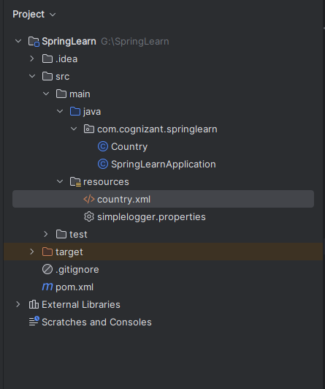

**========================================================**

**Final Output**



